RESEARCH PROPOSAL FORM
(also referred to as the ‘Statement of Intent Form’, or SOI)

To be submitted by the researcher to the Institute Research Sub-Committee (IRC)

Research Title:
Recognizing the sequential state of knots for educational purposes.

Institute name
Institute of Information and Communication Technology
Course / Programme:
Bachelor of Science (Hons.) in Software Development
Level and year of study
Level 6 Year 3
Main area of study being proposed:
The main area of study here is the computer-based assessment of the current state of a knot being created by a user and thus the identification of any incorrect steps. The idea is that someone learning how to tie a knot would have a reference guide and would be attempting to do it. Using computer vision any incorrect steps would be identified while as the correct step would also be recognized and automatically shifting to the next step.

Name of Researcher:  Alvin Cassar | Researcher’s I.D. Number:  76402(L)
Signature of Researcher  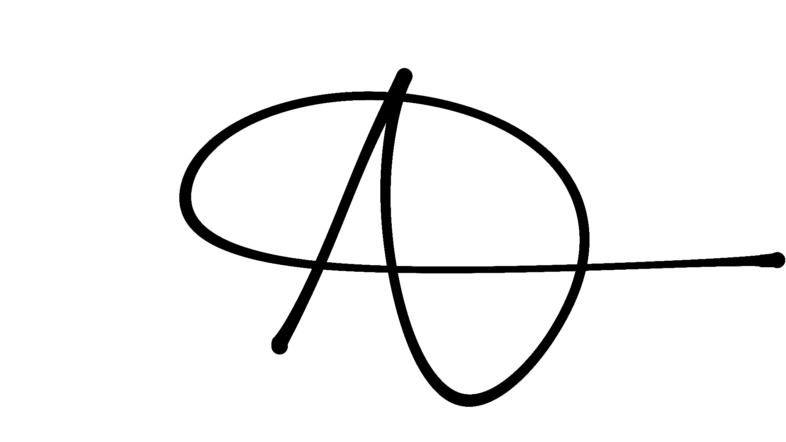 | Date of submission of Form  23/05/2022
Name of Tutor (or Recommended Tutor):
Gerard Said, Daren Scerri

Personal Motivation for the Choice of Research Theme.
I am motivated to do this idea as it correlates with my second-year project where I trained an algorithm to detect between different knots. The motivation for knotting comes from the 13 years I have been in scouting and if done correctly this can also be tested and used to help us leaders teach young kids knotting, in a different way that has not been done before.

After doing the initial research in the subject matter, I have identified that support material is limited to animated visual images or visual guides on how to do the process of tie a knot. Yet there is not currently a solution that does this visual assessment on the current process.

Outline of Key Literature and Theoretical Framework or Propositions.
- Lui and Saxena (2013) used an RGB-D camera to detect the rope and a robot with 2 arms was used to untangle a knot. This was tested using 5 types of materials for rope and 10 different knot types varying in difficulty and complexity. As the camera was built inside the robot it was limited to the Kinect sensor built in. The three main problems tacked with because of this sensor were:

- Resolution of the sensor.
- Obstruction of rope sections happens when the rope overlaps itself.
- RGB data misaligns with the depth points which would further reduce the accuracy.

Using ticker ropes such as polyester ropes and power cables was a solution to the resolution of the sensor. By segmenting the rope into a collection of points and labelling them one after the other the study shows that the issue of overlapping itself was mostly fixed.

Finding the optimal moves and solution to untangling the knot was done by creating their own grading system and grading the solution corresponding to the move set and current state of the knot. Then by choosing the top scoring solutions while repeating the process the best solutions were found. Results show that with an average of 4.75 moves this was 76.9% affective losing most percentages because of the robot and physical limitations.

- Another more recent study about untangling knots was done, this study focused on less rope materials and fewer knots compared to the study before. As the idea of untangling knots was not novel, dense(tighter) knots was never tried to be solved with an automatic system.

By presenting 2 algorithms this would fix previous studies problems, such as lack of space between the crossings of adjacent segments or bends on a smaller scale. Using Basic Reduction of Under-Crossing Entanglements (BRUCE), this algorithm undoes one crossing at a time until the cable is untangled. While the Hierarchical Untangling from Learned Keypoints (HULK) algorithm with the use of visual input to locate pin and pull points. Using the da Vinci Research Kit robot to undo dense overhand and figure-eight knots HULK learned to identify the most suitable positions to pin and pull for the best results. This was also tested on different cable textures (smooth cable, braided rope, cylindrical capsules).

This study was mostly different to the previous in how the cable was split into segments, rather than having equal sections according to the length of the rope this study shows a way to label a cable as seen in the picture below.
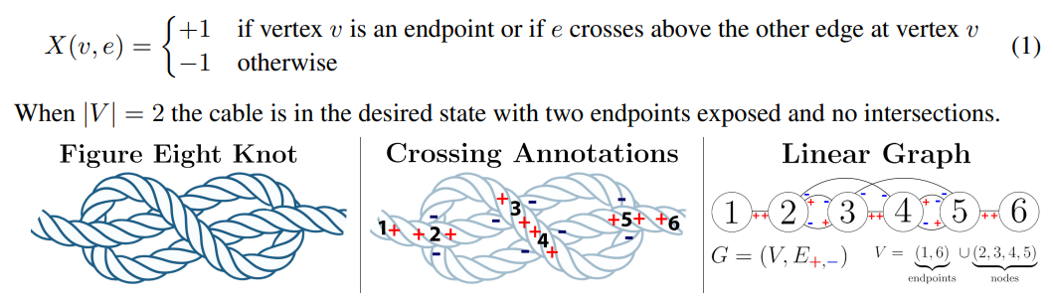

At the conclusion it was suggested by simulation experiments that HULK trained with BRUCE as an algorithmic supervisor had the better results when comparing a various textures and knot configurations. As for untangling a dense knot it was calculated that it took 3-18 actions with well-over 50% success rate.

- The last study shows the 9 current uses of AI in operating rooms. With the approach that it is being taken to my knot tying application, this study shows how affective it can be to improve such technologies.

Knot-Tying
It was researched that knot tying in open surgery is a crucial skill but also a basic skill. Being in an intensive time taking up to 3 minutes to tie a knot is a long time. With the use of humans performing knot-tying to the network and over time the algorithm learns the process. At first tying the knot in 33.7 seconds was already improving the time by 2.5minutes – after learning from 50 more runs the knot was able to be done in 25.8 seconds further improving the model.

Phase Recognition
The use of phase recognition was done to understand what state is being done in a surgical process. With a combination of CNN and RNN this was able to be done in real-time video, while having 86% success rate. It was also found that in another study with a combination of CNN and hidden Markov models (HMMs) there was a 90% accuracy but only using external videos.

Significance of the Study.
This study aims at identifying the possibility of using computer vision for the recognition of the current state of tying a knot to aid in the learning process. Offering insight on the opportunity to enhance the current educational content available.

Hypotheses and/or Research Question/s
We hypothesize that it will be possible to recognize the state of the rope while identifying the different phases in tying a knot using computer vision, to aid in the learning process.

- What key features and characteristics of the data set are needed for proper training of a model?
- What algorithms can be used for the recognition of the different phases in tying a knot?
- Does the public see a benefit in this solution?

Target Participants and Research Methods for Data Collection and Analysis
So, the target participants of this research are individuals who are attempting to tie knots, which can be rope knots, textile knot such as ties, bowties and scarfs or others. For that reason, first research shall be undertaken in identification of existing data sets and algorithms. Secondly, the development of a proof-of-concept prototype that makes use of computer vision that recognizes the state of a knot tied to aid the individual. Finally, a research experiment where individuals utilize the prototype and offer feedback on the useability.

Anticipated Contributions of the Study.
The contribution of the study is an insight of the use of computer vision for learning purposes in tying knots. It is essentially a proof of concept on the potential release on a real-world prototype.

Dissertation Project Plan.
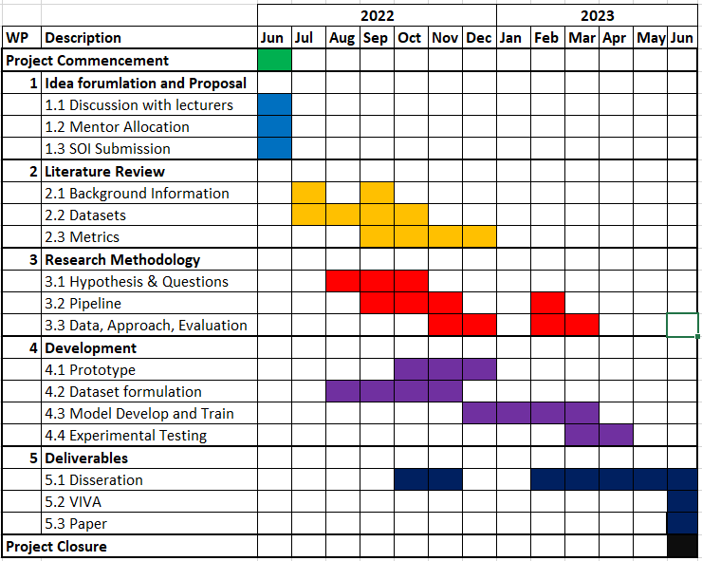

Ethical Considerations.
Refer to guidance points below. You are also additionally required to read MCAST Document 074 ‘Research Ethics Policy and Procedure’ that is available on the College website
Research shall be conducted in such a manner so as to avoid any psychological and physical harm to humans and animals and financial damage to organizations:
- Only the supervisor and examiners will have access to any data gathered.
- Participants will remain free to withdraw from the study at any time without having to provide any reason. In the case of withdrawal, all the records and information collection will be deleted.
- The participant, who is the sole proprietor of the data provided, is granting that such data would be processed for this study purposes only.
- The data collection process will be a transparent process.
- All transcriptions and/or electronic recordings reflecting the data collected, once exhausted, are to be deleted
- Confidentiality, anonymity and data protection procedures are to be ethically abided by.
- The researcher would provide a soft copy of the study to the participant, if required.

Enter details here regarding possibility of issues regarding confidential personal data:
No personal data will be gathered, all interviews will be anonymized.

Enter details here regarding possibility of physical harm:
Not applicable.

Enter details here regarding possibility of moral harm:
Not applicable.

Enter details here regarding possibility of business harm:

Not applicable.

Please see Annex 1 for a sample Participant Information Letter and Annex 2 for a sample Participant Consent Form. Student is to submit a copy of the proposed Participant Information Letter and Participant Consent Form where applicable. Both documents should be attached to the end of the SOI that is being submitted by the student.

List of Key References:

[1] W. H. Lui and A. Saxena, "Tangled: Learning to untangle ropes with RGB-D perception," 2013 IEEE/RSJ International Conference on Intelligent Robots and Systems, 2013, pp. 837-844, doi: 10.1109/IROS.2013.6696448.

[2] Grannen, J., Sundaresan, P., Thananjeyan, B., Ichnowski, J., Balakrishna, A., Hwang, M., Viswanath, V., Laskey, M., Gonzalez, J.E. and Goldberg, K., 2020. Untangling dense knots by learning task-relevant keypoints. arXiv preprint arXiv:2011.04999.

[3] Birkhoff, D.C., van Dalen, A.S.H. and Schijven, M.P., 2021. A review on the current applications of artificial intelligence in the operating room. Surgical innovation, 28(5), pp.611-619.

This section is to be filled in by the representative of the Institute Research Sub-Committee (IRC) prior to forwarding of this Form to the ‘MCAST Research Ethics Committee’ for final ethics approval:
Nature of Ethical Consideration | Outcome (Tick) | Comments/Advice
All ethical issues have been adequately tackled.
Possibility of issues regarding misuse of data or some form of harm.

Details of Representative to the Institute Research Sub-Committee.
Name | Signature
Designation | Date

Annex 1: Participant Information Letter

Sample: 
Title of Research: ___________________________________________________________________
You are being invited to take part in a research study. Before you decide to participate, it is important for you to understand why the research is being done and what it will involve. Please take time to read the following information carefully and discuss it with others if you wish. Ask us if there is anything that is not clear or if you would like more information.
What is the purpose of the study?
This research is being undertaken on…

Why have I been chosen?
You have been chosen because…

Do I have to take part?
It is up to you to decide whether or not your take part. If you decide to take part you will be given this information sheet to keep and be asked to sign a corresponding consent form.

What will happen to me if I take part?
You will then be given a questionnaire on.../your data will be used…/your image will be used…

What are the possible disadvantages and risks of taking part?
There are no disadvantages or risks foreseen in taking part in the study.

What are the possible benefits of taking part?
By taking part you will be contributing to the development of a set of recommendations for…

What if something goes wrong?
If you wish to complain or have any concerns about any aspect of the way in which you have been approached or treated during the course of this study, please contact…(researcher is to give his/her MCAST email as a contact)

Will my details be kept confidential?
All information which is collected about you during the course of the research will be kept strictly confidential so that only the researcher carrying out the research will have access to such information and will not be shared with any other individuals. Participants should note that data/images collected from this project may be retained and published in an anonymized form. By agreeing to participate in this project, you are consenting to the retention and publication of data.

What will happen to the results of the research study?
The results will be written up into a dissertation for my final project of my Bachelor…

Who is organizing the research?
The research is conducted as part of a degree in …

Who may I contact for further information?
If you would like more information about the research before you decide…(researcher is to give his/her MCAST email as a contact)

Thank you for your interest in this research…
Annex 2: Participant (or Guardian) Consent Form

Sample:

Title of Research: ____________________________
Name of Researcher: ___________________________

Please initial box

- I confirm that I have read and understand the Information Letter
for the above study and have had the opportunity to ask questions.
- I understand that my/my charge’s participation is voluntary and that I/my charge am/are free to withdraw at any time without giving any reason.

3. I agree to allow my daughter/son/charge to take part in the above study.
(Statement 3 is to be included only when guardians/parents are involved in giving consent)

___________________ _________________ _____________
Name of Participant/
Guardian Date Signature

Researcher Date Signature

1 for participant; 1 for researcher

